**Analysis of Dispersal Plasticity in *Lasthenia fremontii***

Jackson Anderson

BioStats 2020 Final Project

**Background:**

Over the course of the 2019 Fall semester, the students of Nancy Emery's Evolutionary Ecology class (EBIO 4450) conducted and experiment where they subjected a plethora of l. fremontii plants to varying forms for environmental stress. This study was conducted at the CU Greenhouse on 30th Street. Three different experiments were run for this class, all of them looking at how the manipulation of environmental parameters affected plant biomass, the ratio of dispersive to non-dispersive seeds produced by the maternal plant, and the height of the inflorescence, measured from the base of the plant. One experiment, called the "shade" experiment, subjected groups of plants to different levels of light. Another experiment, the "density" experiment, planted 1 or two plants per cone as a measure of competition. The final experiment, the "resource" experiment, subjected plants to varying degrees of available nutrients, another measure of environmental stress. Data was collected near the end of the semester, and each experimental team analyzed their data, with help from Dr. Emery and those that worked in her lab. After the semester ended, as a member of Dr. Emery's lab, was given the opportunity to perform a meta analysis on all the data collected from each experiment, as well as execute more rigorous testing than we had time for during the class itself. Suffice it to say that the results from this analysis differed substantially from those of the actual class.

Much of the data parsing was done early in the Fall semester; preliminary visualization and modeling was done during mid Fall semester; over the past few days, models were tweaked and re-worked and these results were interpreted with more scrutiny. I am bummed that I was not able to use my original data set for this assignment, and I learned the hard way to make sure the data fits the assumptions of the models needed to perform the analysis. As well, it should be noted that this data set is somewhat incomplete, as there is survivorship data on some plants from the density experiment have yet to be tallied. When the pandemic hit, it became very difficult to coordinate between my former classmates that ran this experiment, as some left the country to do fieldwork in Norway. Thus, survivorship status was taken into account, when possible. All-in-all, this analysis is still a work-in-progress. Enjoy!!

**Experimental Assumptions:**

Really, the only assumptions made for these experiments is that plant biomass can be used as a measure of stress. The use of inflorescence height was statistically tested for as a dispersal trait by the class, and similarly, several studies have found that maternal plant architecture influenced how seeds were dispersed (de Casas et al., 2012; Donohue, 1998). As well, seed phenotype proportion (dispersive to non-dispersive seed ratio) as a measure of dispersal propensity is widely supported ((Donohue, Polisetty, & Wender, 2005; Imbert & Ronce, 2001; Teller, Campbell, & Shea, 2014).

**Hypotheses**

1. Nutrient concentration will have an effect on plant biomass, the proportion or dispersive to non-dispersive seeds, and inflorescence height.
2. The number of plants in a cone will have an effect on plant biomass, the proportion or dispersive to non-dispersive seeds, and inflorescence height.
3. Access to light will have an effect on the plant biomass, the proportion or dispersive to non-dispersive seeds, and inflorescence height.

**Predictions**

1. Plant biomass will decrease with increasing nutrient concentration; the ratio of dispersive to non-dispersive seeds will increase with nutrient concentration; focal flower height will increase with nutrient concentration
2. With increasing competition, plant mass will decrease; dispersal propensity (seed ratio) will increase with competition; focal flower height will increase with competition
3. Plant biomass will decrease with less access to light; dispersal propensity will be inversely associated with light level; focal flower height will be inversely associated with light level.

**Statistical Methods:**

Data on surviving plants were analyzed and results modeled in Rstudio, v 4.0.2. Most of the data collected for this study had underlying heteroskedasticity. Unfortunately, log transformation of the response variable did not sufficiently address the issue of unequal residual variances. As a workaround, two variations of a linear mixed-effects model were used to determine response variable behavior to treatment effect: one model accounted for an unequal variance structure in residual variances while the other assumed an underlying normal residual distribution. Both models were pulled from the “nmle4” package. Both models used the experimental predictor (nutrient concentration, competition level, shade level) on all three response variables (inflorescence height, dispersal propensity, plant biomass). As well, both models incorporated the location of the bin holding the plants in the greenhouse as a random effect variable. Model fit was addressed using an anova, and the choice to use either the equal or unequal variance model was justified based on its AIC, BIC, or LogLik value, where applicable. In the case of the dispersive to non-dispersive seed proportions in the density experiment, neither equal nor unequal variance linear mixed effects models accounted for the unequal residual variances seen; a beta GLM model was run from the betaglm package available to R, but this, too, did not address the issue. For this specific case, the equal variances model was used to communicate the results, as use of both the beta GLM and the unequal variances models was not justified based on it AIC, BIC, and LogLik value relative to the simpler model. Once models were run, data was plotted by experiment and treatment type using ggplot2. It should be noted that Bonferroni correction was not applied to alpha values for the seed morph ratio and inflorescence height models. Though they are both means of measuring a plants ability to disperse it’s seed, variation in inflorescence could be interpreted as a stress response instead of a dispersal trait response if the environment was exceptionally stressful on the plant. Given the potential duality of this trait, it was left as independent of both plant biomass and seed morph proportion.

**Results:**

Treatment Effects on Plant Growth / Maternal Plant Condition

*Did our treatments impose stress as intended?*

Shade Experiment

Decreasing light levels on above-ground biomass in the Shade experiment had very little effect. Although mean biomass declined slightly with increasing levels of shade, there were no statistically significant differences between the Control treatment and any of the shade treatments (Low (87.20 umol*s/m2), Medium (71.60umol*s/m2), or High (69.00 umol*s/m2), (p = 0.48, F(4,35)= 0.90)). The Structural treatment (107.00 umol*s/m2) was also not statistically different from the Control (122.00 umol*s/m2), though the average above-ground biomass was lowest in the Structural Control compared to all other treatment levels (Fig.1).

Density Experiment

Above-ground biomass was similar across treatment levels in the Density experiment, suggesting that the addition of one or two plants in a cone did not substantially increase competition for the focal *L. fremontii* individuals. There was no significant treatment effect on vegetative biomass for the density experiment (p = 0.13, F(2,72) = 2.12). Plants raised with two competitors produced substantially less biomass on average when compared to the control, but within-treatment variation obscured differences among groups; in fact, the individual with the highest above-ground biomass in this experiment was actually raised with two competitors (Fig.1).

Eutrophication Experiment

In the Eutrophication experiment, there was a significant overall treatment effect on vegetative biomass (p < 0.001, F(2,25) = 10.30). Both the low (0.5x) and medium (1x) treatment groups were seen to have a significant effect on vegetative biomass when compared to the control. Plants raised in the low treatment produced 1.2x more biomass than that of the control (p < 0.01, t(25)= 3.16, se = 0.118). Plants raised in the medium treatment group produced ~38% less above ground biomass than that of the control (p < 0.05, t(25) = -2.25, se = 0.05), indicating that the 1x eutrophication treatment was more stressful than lower nutrient levels for *L. fremontii*. Mean above-ground biomass differed significantly between the low and medium treatment groups as well. Mean vegetative biomass in the low treatment was ~2.6x greater than that of the medium treatment category. (p < 0.001, t(25) = 4.27, se = 0.12). Plants raised under the 5 additional treatments of increasing nutrient addition (1.25x, 1.5x, 1.75x, 2x, and 2.25x) had such low survivorship that there were too few replicates to include these treatments in the statistical analysis. Collectively, the responses of *L. fremontii* to the eutrophication treatments indicate that the 0.5x treatment was beneficial (relative to the control), the 1.0x was stressful (relative to the control and the 0.5x treatment), and anything exceeding 1.0x was essentially toxic (Fig.1).

Plasticity in Dispersal Traits

*Proportion of ray relative investment into non-dispersive seeds*.

Shade experiment:

The proportion of non-dispersive to dispersive seeds produced by the maternal plant did not differ substantially across treatment groups in the shade experiment (p = 0.86, F(4,36) = 0.33). Though the control and low shade group had the highest mean seed ratios, there was no significant treatment effect on seed proportion for the shade experiment. These results suggest that the gradient of light exposure used in this experiment was not a significant form of stress on dispersal propensity of the maternal plant (Fig.2).

Density experiment:

There was no difference in Investment in non-dispersive seeds relative to dispersive seeds among treatments in in the density experiment (p = 0.32, F(2,73) = 1.13). These results suggest that competition did not influence the relative production of dispersive or non-dispersive seeds (Fig.2).

Eutrophication experiment:

The resource experiment saw investment in seed proportion remain similar among all treatments relative to the control (p = 0.12, F(2,26) = 2.24). This indicates that a maternal plant’s energy investment in dispersive or non-dispersive seeds was not affected by the utilized nutrient gradient (Fig.2).

Plant Height

*Height of inflorescence*

Shade Experiment

There was no clear trend in focal flower height as it varied by treatment in the shade group (p = 0.17, F(4,32) = 1.72). The low treatment and the medium treatment had the highest mean focal flower heights in test, however, these results are meaningless given the model results (Fig.2).

Density Experiment

Focal flower height within the density experiment was similar across all treatment categories (p = 0.40, F(2,58) = 0.95). The low treatment category had a higher mean focal flower height than both the control and medium treatments, however there was substantially more within-group variation than among-group variation. These results suggest that increased competition had no effect on the focal flower height (Fig.2).

Resource Experiment

There was a clear negative trend in focal flower height with increasing treatment effect in the eutrophication experiment, though these effects were statistically marginal (p = 0.053, F(2,22) = 3.36). Mean focal flower height for the medium treatment was ~ 44% less than that of the control (p < 0.05, t(22) = -2.57, se = 1.42). Mean focal flower height in the low treatment category was not statistically different from that of the control (p = 0.55, t(22)= -0.62, se = 1.17). Mean focal flower height in the low treatment category was 69% greater than that of the medium treatment category, though this difference was marginal (p = 0.06, t(22)= 1.50, se = 1.50). Given that the overall effect of the treatments themselves on focal flower height was marginal, this trend does not rest on solid statistical grounds (Fig.2).

**Figures:**

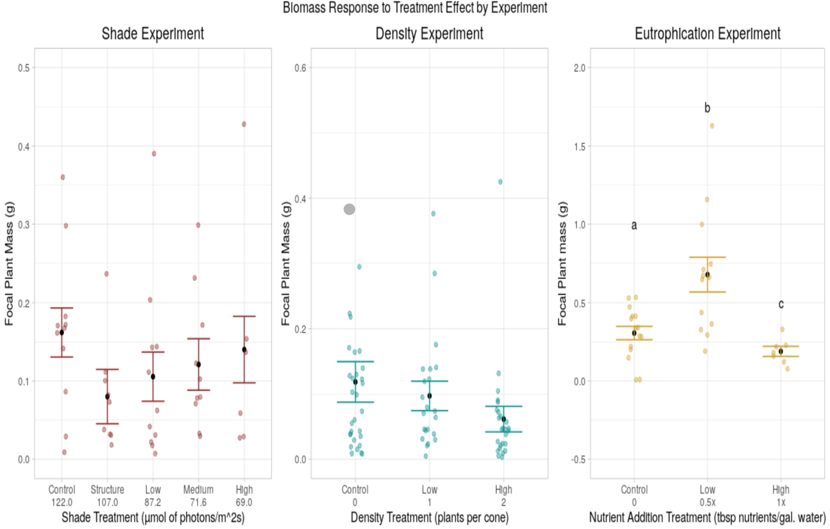Figure 1

*Figure 1: Here, we can see the effects of each experimental treatment on Focal Plant mass, as measured in grams. There was no significant treatment effect for the shade or density experiments. In the resource experiment, however, there was a significant treatment effect (p < 0.001, F(2,25) = 10.30).*

Figure 2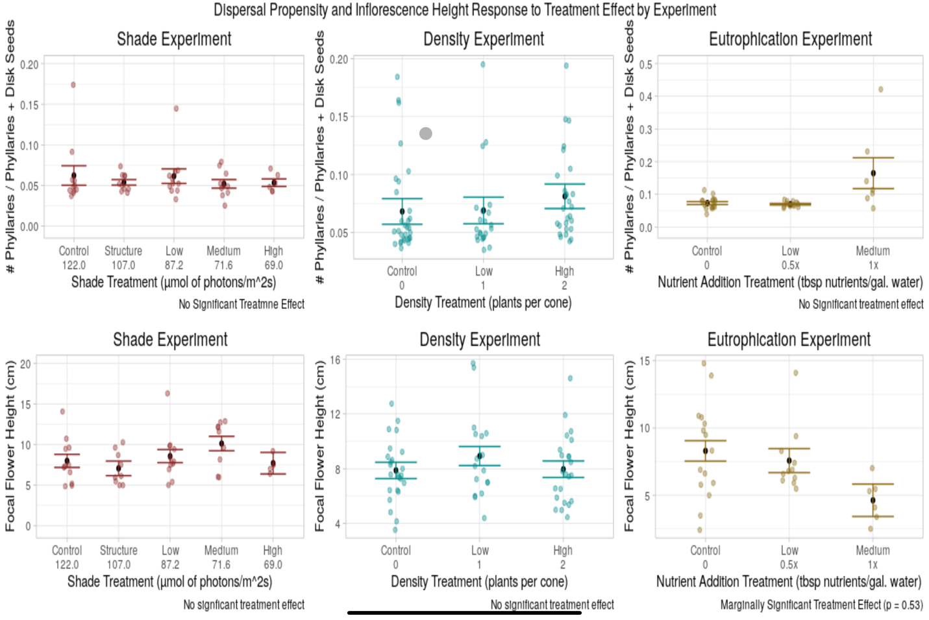

*Figure 2: Here, we can see how each experimental treatment affected dispersal propensity and focal flower height. It should be noted that there was no significant treatment effect among all experiments; the resource (eutrophication) experiment, however, had a marginally significant effect (p = 0.053, F(2,22) = 3.36).*

**Discussion:**

It would appear that, among experiments, only plants in the nutrient experiment responded significantly to treatment effects. While measures of stress did not differ significantly within treatments for the shade and density experiment, they did within the resource experiment, with the highest form of stress being that of the medium treatment category (or 1x fertilizer addition relative to the control). As well, we may have stumbled upon an optimal range for nutrient concentration for *L. fremontii* in the "low" treatment category, as it's mean plant biomass was significantly larger than that of the control's. Dispersal traits within the shade and density experiment did not differ significantly among treatment categories, suggesting that, in such circumstances, competition and varying access to light have no effect on traits associated with dispersal, and thus we cannot make any inferences on how these environmental conditions might affect plant fitness. Within the nutrient experiment, we did see a marginal treatment effect on inflorescence height, suggesting a potential negative relationship between increasing eutrophication and inflorescence height. Lower inflorescence heights are often associated with a propensity to disperse close to the maternal plant, however it seems unlikely that an increase in available nutrients was associated with selection for these traits; rather, if we look at how tall a plant grows as a measure of perceived stress, more eutrophic environments might be associated with more stress, and thus a lower inflorescence height might be an indication of higher stress levels, not a response to a favorable immediate environment. This idea also makes sense given that biomass was lowest in the more eutrophic environments. Had the range of available nutrients within this experiment been subsequently narrowed to the 0x – 1x range, we may have been able detect how nutrient availability affected inflorescence height as a dispersal trait.

**Shortcomings of this analysis: a personal note**

I feel that it is very important to note that, even with the unequal variance structure models, the diagnostics did not look great. Given that this analysis is still a work in progress, this may change when more data is added. That being said, this entire analysis, regardless of its thoroughness, should be treated as a preliminary analysis, and all results should be interpreted under that stipulation. I was consistently reminded throughout this entire process of the imperfect nature of the real world, and how expectations of achieving something of biological significance, simply put, might not be achievable. In any case, working with the data set and the people involved has been such an incredible learning experience, and I can’t wait to continue working on it.

**Acknowledgments:**

I want to thank Dr. Nancy Emery and Courtney Van dan Elzen for their continued support and help throughout this entire experience. Not only did Dr. Emery give me the opportunity to head up data analysis for such a big project, but she provided moral support and words of encouragement throughout. As an undergrad that’s still learning all of this stuff, having such a mentor has been a complete blessing. Courtney gave me very insightful advice on modeling and how to deal with problematic data, and I appreciate to no end her constant willingness to help. As well, Dr. Andrew McAdam gave me so many new tools to approach this data set with, and that made this entire process much more rewarding and enjoyable!

**Works Cited:**

* de Casas, R. R., Willis, C. G., & Donohue, K. (2012). Plant dispersal phenotypes: a seed perspective of maternal habitat selection. In J. Clobert, M. Baguette, T. G. Benton, & J. M. Bullock (Eds.), Dispersal Ecology and Evolution (pp. 171–184). New York: Oxford Univ Press.
* Donohue, K. (1998). Maternal determinants of seed dispersal in Cakile edentula: Fruit, plant, and site traits. Ecology, 79(8), 2771–2788. doi: 10.1890/0012-9658(1998)079[2771:MDOSDI]2.0.CO;2
* Donohue, K., Polisetty, C. R., & Wender, N. J. (2005). Genetic basis and consequences of niche construction: Plasticity-induced genetic constraints on the evolution of seed dispersal in Arabidopsis thaliana. American Naturalist, 165(5), 537–550. doi: 10.1086/429162
* Imbert, E., & Ronce, O. (2001). Phenotypic plasticity for dispersal ability in the seed heteromorphic Crepis sancta (Asteraceae). Oikos, 93(1), 126–134. doi: 10.1034/j.1600-0706.2001.930114.x
* Teller, B. J., Campbell, C., & Shea, K. (2014). Dispersal under duress: Can stress enhance the performance of a passively dispersed species? Ecology, 95(10), 2694–2698. doi: 10.1890/14-0474.1

R Packages:

Tidyverse:

Wickham et al., (2019). Welcome to the tidyverse.

Journal of Open Source Software, 4(43), 1686,

https://doi.org/10.21105/joss.01686

Nlme:

Pinheiro J, Bates D, DebRoy S, Sarkar D, R Core Team (2020). _nlme: Linear and Nonlinear Mixed

Effects Models_. R package version 3.1-149, <URL: https://CRAN.R-project.org/package=nlme>.

Lattice:

Sarkar, Deepayan (2008) Lattice: Multivariate Data Visualization with R. Springer, New York.ISBN 978-0-387-75968-5

Lmtest:

Achim Zeileis, Torsten Hothorn (2002). Diagnostic Checking in Regression Relationships. R News 2(3), 7-10. URL https://CRAN.R-project.org/doc/Rnews/

Knitr:

Yihui Xie (2020). knitr: A General-Purpose Package for Dynamic Report Generation in R. R package version 1.29.

Yihui Xie (2015) Dynamic Documents with R and knitr. 2nd edition. Chapman and Hall/CRC. ISBN 978-1498716963

Yihui Xie (2014) knitr: A Comprehensive Tool for Reproducible Research in R. In Victoria Stodden, Friedrich Leisch and Roger D. Peng, editors, Implementing Reproducible Computational Research. Chapman and Hall/CRC. ISBN 978-1466561595

Grid/GridExtra:

R Core Team (2020). R: A language and environment for statistical computing. R Foundation for Statistical Computing, Vienna, Austria. URL https://www.R-project.org/.

Wesanderson:

Karthik Ram and Hadley Wickham (2018). wesanderson: A Wes Anderson Palette Generator. R package version 0.3.6. https://CRAN.R-project.org/package=wesanderson

Rstudio:

R Core Team (2020). R: A language and environment for statistical computing. R Foundation for Statistical Computing, Vienna, Austria. URL https://www.R-project.org/.